Advance Python Programming
- Printing on Screen
- Introduction to the print() function in Python.
  - The print() function is a built-in Python function used to display information to the console or other standard output devices. It is the most common way to interact with users or debug code during program execution.
Syntax :
print(object(s), sep=' ', end='\n', file=sys.stdout, flush=False)

Parameters :
- value(s): Any value, and as many as you like. Will be converted to a string before printed
- Sep ='separator' : (Optional) Specify how to separate the objects, if there is more than one.Default :' '
- end='end': (Optional) Specify what to print at the end.Default : '\n'
- file : (Optional) An object with a write method. Default :sys.stdout
- flush : (Optional) A Boolean, specifying if the output is flushed (True) or buffered (False). Default: False
Ex :
- Printing a Simple message
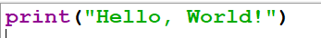
- Printing Multiple Values
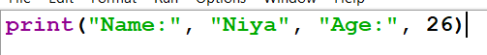
- Using sep parameter
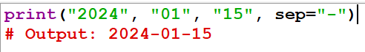
- Using end parameter
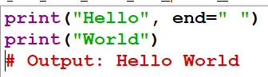
- Printing Variables
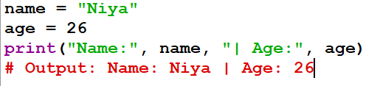
- Using f-strings (Formatted Strings)
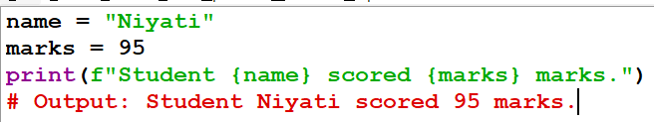

- Formatting outputs using f-strings and format().
  - f-strings (Formatted String Literals)
    - Introduced in Python 3.6, f-strings are the most modern and readable way to format strings.
Syntax:
prefix the string with f and embed expressions in {}
Ex :
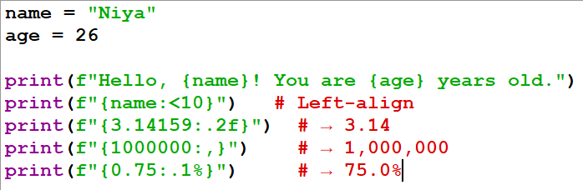
  - str.format() Method
    - The format() method works in Python 2.6+ and 3.x — useful for older codebases or templates.
Syntax:
use {} placeholders and pass values to .format()

Ex :
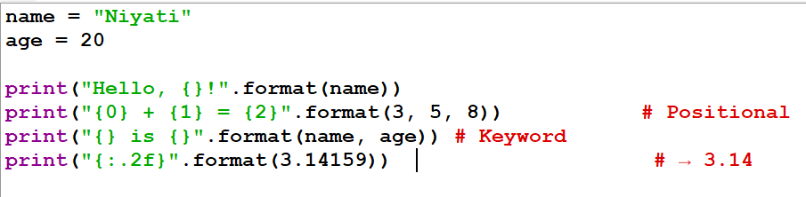
- Reading Data from the Keyboard
- Using the input() function to read user input from the keyboard.
  - In Python, the input() function is used to take input from the user through the keyboard. It allows interaction between the user and the program.

Syntax
input("message")
Ex :
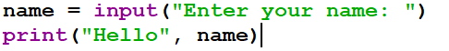
- Converting user input into different data types (e.g., int, float, etc.)
  - In Python, the value entered using input() is always treated as a string. To perform calculations, we must convert it into the required data type using functions like int() and float().
Ex :
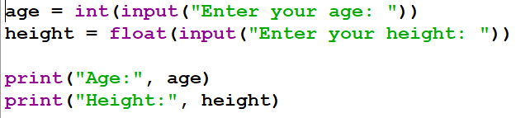
- Opening and Closing Files
- Opening files in different modes ('r', 'w', 'a', 'r+', 'w+').
  - In Python, files can be opened in different modes depending on the operation you want to perform.
File Modes :
- 'r' (Read Mode)
  - Opens a file for reading only. File must exist.
- 'w' (Write Mode)
  - Opens a file for writing. Creates a new file or overwrites existing content.

- 'a' (Append Mode)
  - Opens a file to add data at the end without deleting existing content.

- 'r+' (Read and Write Mode)
  - Opens a file for both reading and writing. File must exist.

- 'w+' (Write and Read Mode)
  - Opens a file for reading and writing. Overwrites the file if it exists.

- Using the open() function to create and access files.
  - The open() function is used to open an existing file or create a new file in Python.
Syntax :
file = open("filename", "mode")
Ex :
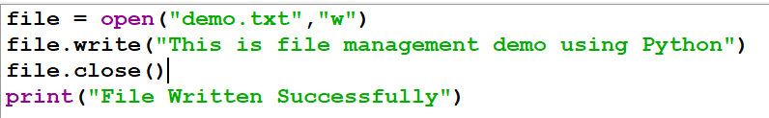
- Closing files using close().
  - After working with a file, it is important to close it using the close() method.
Syntax :
file.close()

Ex :


- Reading and Writing Files
- Reading from a file using read(), readline(), readlines().
  - In Python, files can be read using different methods depending on how much data you want to access.
- read() :
  - Reads the entire content as a single string.
Ex :
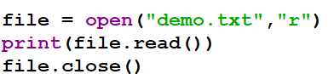
- readline()
  - Reads one line at a time.
Ex :
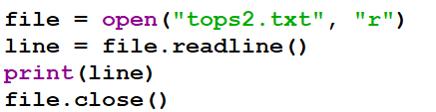
- writelines()
  - Writes a list of strings to a file
Ex :
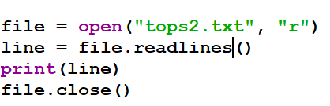
- Writing to a file using write() and writelines().
  - In Python, writing to files allows storing data permanently.

- write() :
  - Writes a single string to a file
Ex : 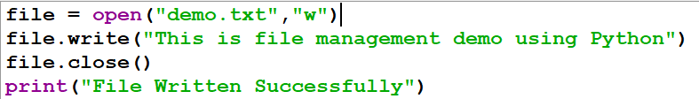

- writelines() :
  - Writes a list of strings to a file
Ex :
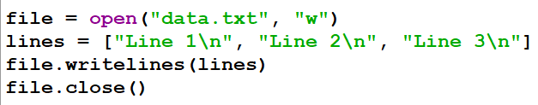

- Exception Handling
- Introduction to exceptions and how to handle them using try, except, and finally.
  - In Python, an exception is an error that occurs during program execution. If not handled, it can stop the program.
  - To handle such errors, Python provides exception handling using try, except, and finally.
Syntax :
try:
# code that may cause an error
except:
# code to handle the error
finally:
# code that always executes

Ex :
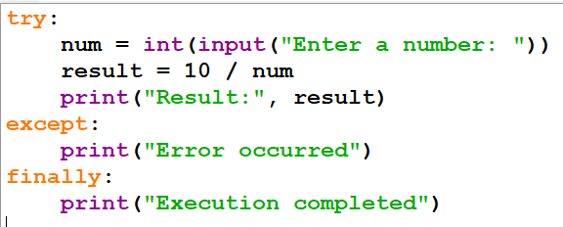
- Understanding multiple exceptions and custom exceptions.
- Multiple Exceptions :
  - You can handle different types of errors using multiple except blocks.
Ex :
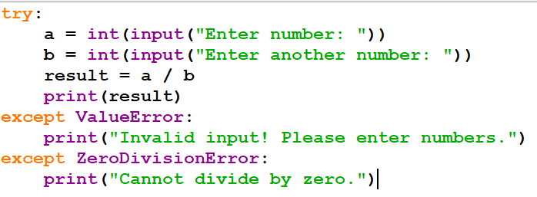

- Custom Exceptions
  - Custom exceptions are user-defined errors using classes.
Ex :
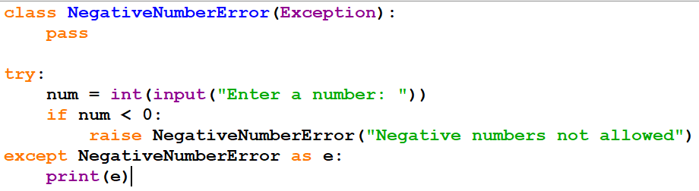
- Class and Object
- Understanding the concepts of classes, objects, attributes, and methods in Python.
  - Object-oriented programming (OOP) in Python centers on organizing code into reusable units called classes and objects.
- Class :
  - A user-defined "blueprint" or template that defines a specific set of data (attributes) and behaviors (methods). You create them using the class keyword.
- Object :
  - A concrete instance created from a class. While a class is the design, an object is the actual entity that occupies memory and holds real data.

- Attributes:
  - Variables that store data for a class or object, representing its state.
    - Instance Attributes: Unique to each object, typically defined inside the __init__ constructor using self.
    - Class Attributes: Shared by all instances of a class, defined directly within the class body.
- Methods:
  - Functions defined inside a class that describe the behaviors or actions an object can perform.
    - Instance Methods: The most common type; they operate on instance data and must include self as the first parameter to reference the current object.

    - Special Methods: Includes magic methods like __init__ (for initialization) and __str__ (for string representation).
Ex :
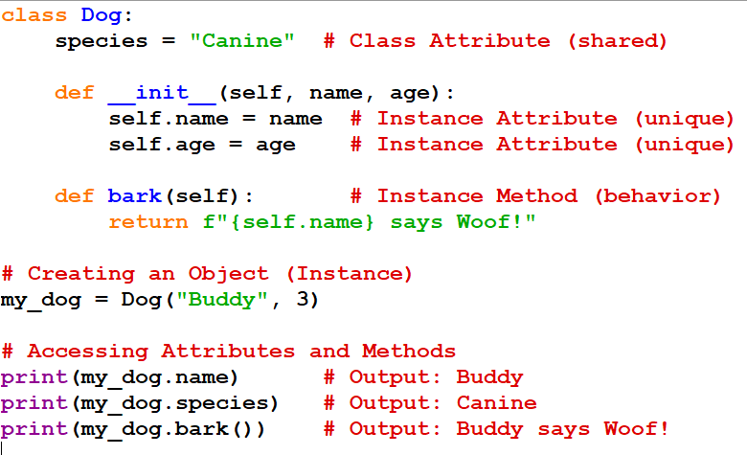

- Difference between local and global variables.
Feature | Local Variable | Global Variable
Scope | Limited to the specific function or block where it is declared. | Accessible from any part of the program, including all functions.
Decalaration | Inside a function, loop, or code block. | Outside of all functions, typically at the top of the program.
Lifetime | Created when the function/block starts and destroyed when it ends. | Exists for the entire duration of the program's execution.
Storage | Typically stored on the stack. | Stored in the data segment of memory.
Default Value | Initialized with garbage values (language-dependent). | Automatically initialized to zero if not set.

- Inheritance
- Single, Multilevel, Multiple, Hierarchical, and Hybrid inheritance in Python.
  - In Python, inheritance allows one class (child) to use the properties and methods of another class (parent). It helps in code reuse and organization.

- Single Inheritance
  - One child class inherits from one parent class.
Ex :
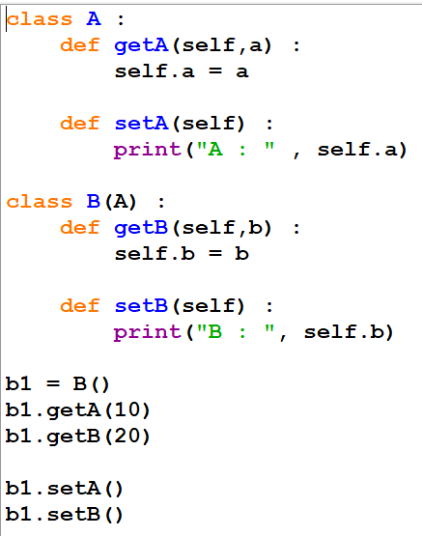

- Multilevel Inheritance
  - A class inherits from another class, which itself is derived from another class

Ex :
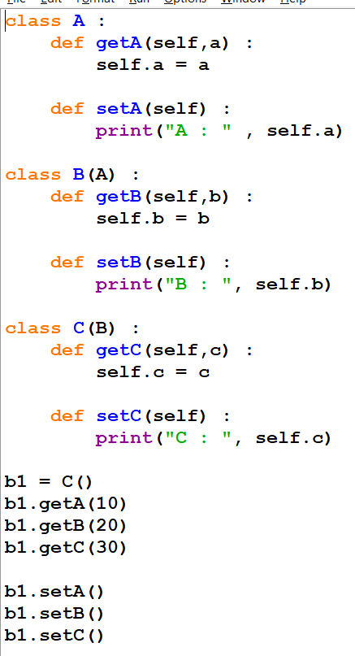
.
- Multiple Inheritance :
  - A child class inherits from more than one parent class.
Ex :
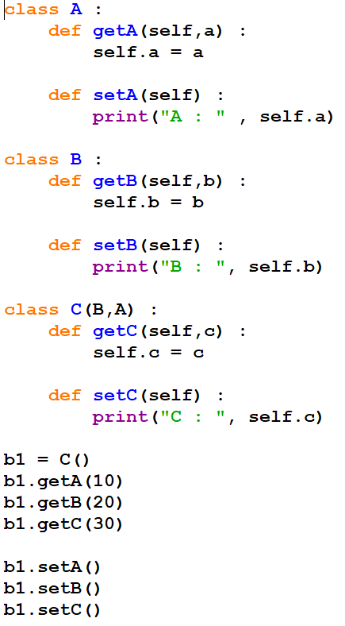
- Hierarchical Inheritance
  - Multiple child classes inherit from one parent class.
Ex :
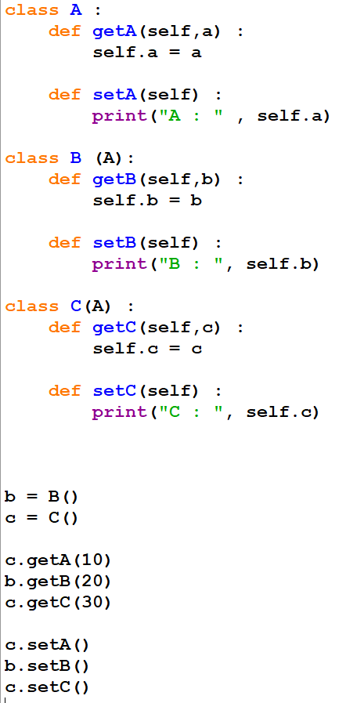
- Hybrid Inheritance :
  - Combination of two or more types of inheritance.
Ex :
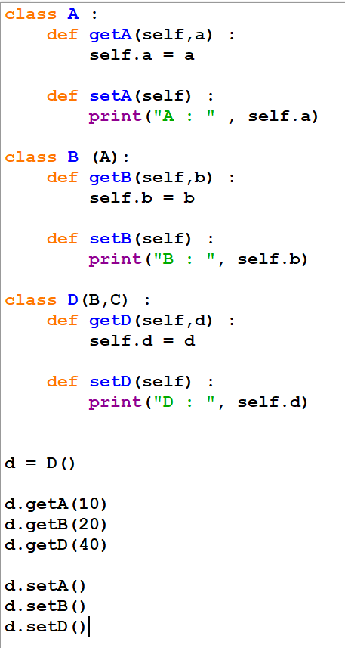
- Using the super() function to access properties of the parent class
  - The super() function is used to call methods or access properties of the parent class from the child class.
Ex :
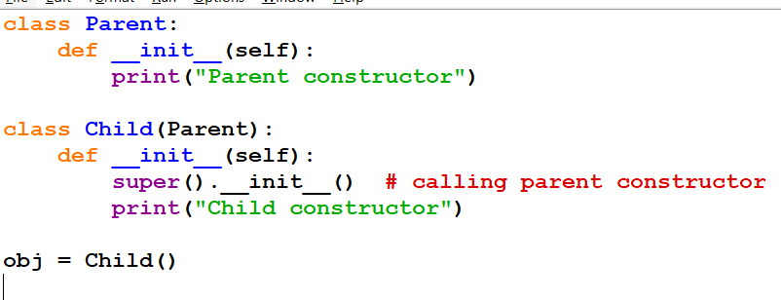

- Method Overloading and Overriding
- Method overloading: defining multiple methods with the same name but different parameters.
  - Method overloading means defining multiple methods with the same name but different parameters.
  - Python does not support true method overloading. Instead, it achieves similar behavior using default arguments or *args.

Ex :
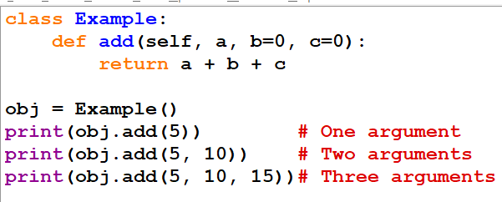
- Method overriding: redefining a parent class method in the child class.
  - Method overriding means redefining a method of the parent class in the child class with the same name.

Ex :
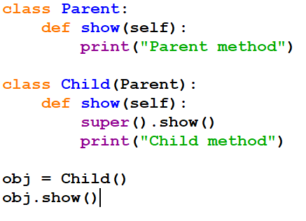

- SQLite3 and PyMySQL (Database Connectors)
- Introduction to SQLite3 and PyMySQL for database connectivity.
  - Database connectivity allows Python programs to store, retrieve, and manipulate data using databases. Python provides built-in and external libraries to connect with different databases.

  - Two commonly used options:
    - SQLite3 → Lightweight, built-in database
    - PyMySQL → Used to connect Python with MySQL databases

- SQLite3 :
  - SQLite3 is a self-contained, serverless, lightweight database
  - Comes pre-installed with Python
  - Stores data in a single file
  - Best for small projects, testing, and local applications
Features :
- No installation required
- Zero configuration
- Fast and simple
- Supports standard SQL

- PyMySQL :
  - PyMySQL is a Python library used to connect to MySQL databases
  - Requires MySQL server (e.g., XAMPP, WAMP)
  - In web development (Django, Flesk) PyMySQL is used

Features :
- Works with MySQL databases
- Supports advanced operations
- Suitable for web applications and large projects

- Creating and executing SQL queries from Python using these connectors.
  - In Python, we can interact with databases by creating and executing SQL queries using connectors like SQLite (sqlite3) and PyMySQL.
  - Steps to Execute SQL Queries
    - Connect to the database
    - Create a cursor object
    - Execute SQL queries
    - Fetch results (if needed)
    - Commit changes
    - Close the connection
Ex :
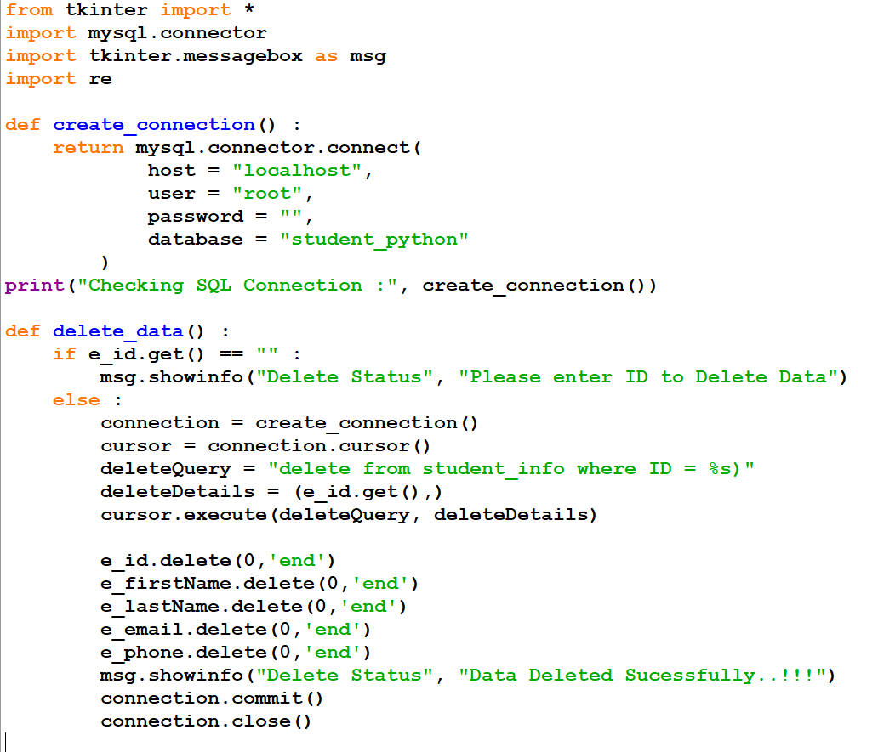
- Search and Match Functions
- Using re.search() and re.match() functions in Python’s re module for pattern matching.
  - In Python, the re module (regular expressions) is used for pattern matching in strings.
- re.search() :
  - Searches for a pattern anywhere in the string
  - Returns the first match if found

Ex :
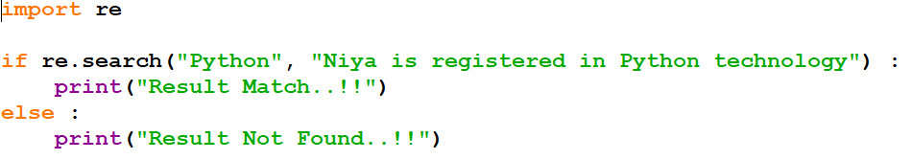

- re,match() :
  - Checks for a pattern only at the beginning of the string

Ex :
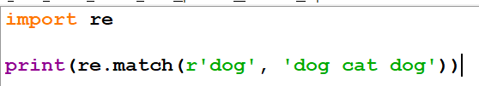
- Difference between search and match.

Feature | re.match() | re.search()
Position | Anywhere in string | Only at beginning
Flexibility | More Flexible | Less Flexible
Use Case | Finding pattern in text | Checking start of string
Ex :
